**The Battle of Neighborhoods**

**Best place to start a Coffee Shop business**

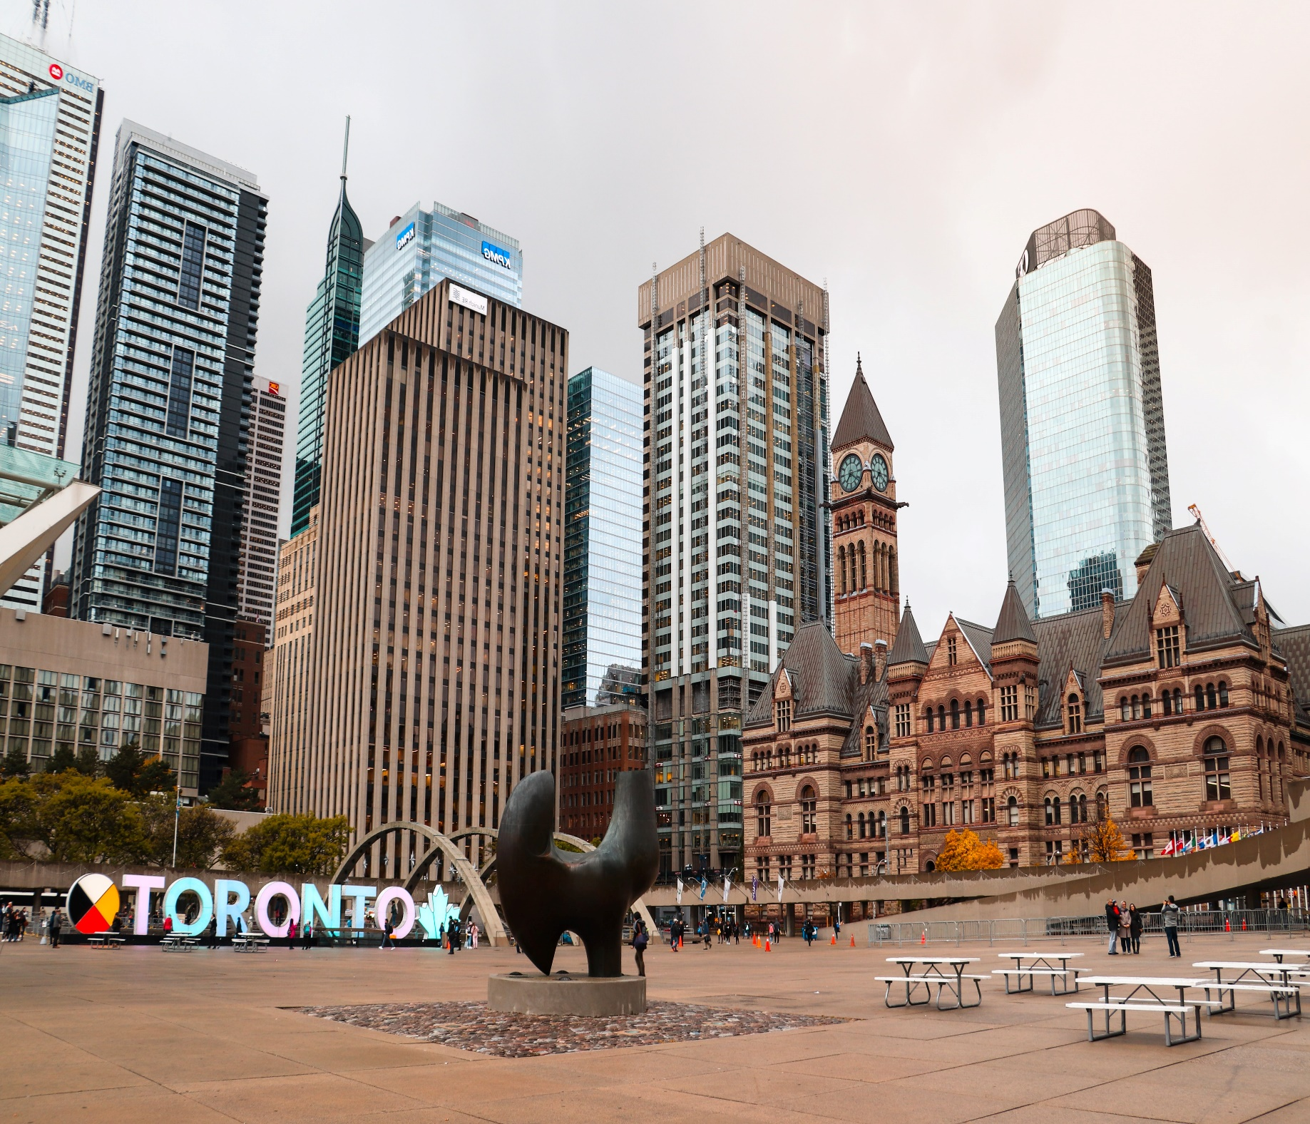

**A. Introduction:**

1.About City Toronto:

Toronto is Canada's largest city and 4th largest city in North America with a population of more than 2.9 million and a density of 4,334.4 people per square kilometer. The city is renowned as one of the most multicultural cities globally due to its large population of immigrants from all over the globe. This leads the city to become a world leader among other metropolitan and cosmopolitan cities from many sectors, including business.

2.Business Problem:

Let’s assume that some would like start Coffee Shop business in city Toronto. But they don’t know which place is better suited for them. To ensure this business success, business team requires insights into the demographics, neighbouring businesses, and crime rates. For each neighbourhood, we can ask:

* How many cafes exist?

* What are the most popular venues?

* Can we get information about the vehicle and foot traffic?

* What is the neighbourhoods’ crime rate? And so on.

Thus, the **project goal** is to figure out the best locations for starting-up a new coffee shop in Toronto City.

**B. Data Description:**

1.Data requirements and collection:

We need historical data about crime incidents, busiest roads, and popular venues. Luckily, Toronto has an open data portal that makes it public. We can also leverage Foursquare Location data to compare neighborhoods in terms of service. Hence, the followings are data sources that we can use for this project:

* [**1st Data**](https://ckan0.cf.opendata.inter.prod-toronto.ca/en/dataset/traffic-signal-vehicle-and-pedestrian-volumes)**:**  
  The most updated record of traffic **signal vehicle and pedestrian volumes** in Toronto City.

Source:

<https://ckan0.cf.opendata.inter.prod-toronto.ca/tl/dataset/traffic-signal-vehicle-and-pedestrian-volumes>

[**2nd Data**](https://data.torontopolice.on.ca/datasets/mci-2014-to-2019):   
The most updated **record of crime incidents** reported in Toronto City provided by Toronto Police Services.

Source: <https://data.torontopolice.on.ca/datasets/4c97cd402c20464a8831adecd1e1c46f_0/explore?location=43.819724%2C-79.295286%2C9.33&showTable=true>

* [**3rd Data**](https://en.wikipedia.org/wiki/List_of_postal_codes_of_Canada:_M):   
  The list of Toronto neighborhoods represented by postal codes and their boroughs.

Source for web scrapping: <https://en.wikipedia.org/wiki/List_of_neighbourhoods_in_Toronto>

* [**4th Data**](https://developer.foursquare.com/):   
  The popular or most common venues of a given neighborhood in Toronto.

Source: https://developer.foursquare.com/

2.Data cleaning and feature extraction:

* The first data is in a CSV file. It contains 2280 rows and 11 columns. The data is typically collected between 7:30 a.m. and 6:00 pm at intersections where there are traffic signals. Each intersection holds vehicle and pedestrian volumes data, along with its coordinates. We will focus on 5 columns; those are **Main**, **8 Peak hour Pedestrian Volume**, **8 Peak hour Vehicle Volume**, **Latitude**, and **Longitude**. We will use these features to diagnose each main road's characteristics and locate the busiest main roads in the city.
* The second data is also in a CSV file. It contains 206,435 rows and 9 columns. The rows represent crime incidents that reported from 2014 to 2019. It has 5 Major Crime Indicators (MCIs) scattered to 17 divisions and 140 listed neighborhoods. We will group the data based on division and get statistics about crime rates.
* The third data is a Wikipedia page about Toronto postal code. We will scrape the page and create a data frame consisting of three columns; **Postal Code**, **Borough**, and **Neighborhood**. We remove any rows that do not have borough assigned. Then, we will be using the **Geocoder** python package to retrieve the **postal code's coordinates**. It will return 103 rows and 5 columns.
* The fourth data is stored inside **Foursquare Location Data**, and we will use **Foursquare API** to access it. We utilize the postal coordinates to retrieve popular venues around a specific radius. As a result, the same venue categories will be returned to different neighborhoods. We can use this idea to cluster the neighborhoods based on their venues representing services and amenities.
* We will run the **k-Means** algorithm to perform this clustering with a different number of clusters (k). The **features will be the mean of the frequency of occurrence of each venue category.** Finally, we can visualize the cluster model using the **Folium** module.

To sum up, we will use the 1st and 2nd data to analyze the pedestrian/vehicle volume and crime rates. Then, we load the 3rd data to obtain the exact coordinates for each neighborhood based on the postal code, allowing us to explore and map the city. Finally, we will use the coordinates and Foursquare credentials to access the 4th data source through its API and retrieve the popular venues along with their details, especially for coffee shops. The venue frequency in each neighborhood will be the features of the clustering model.

**C. Methodology:**

1.Analytic Approach:

We will display any statistics needed to answer questions concerning crime incidents, and vehicle and foot traffic records.

Then, we approach the problem using the clustering technique, namely **k-Means**. This approach enables the audience to see how similar neighbourhoods about their demographics. We can then examine each cluster and determine the discriminating venue categories that distinguish each cluster.

**k-Means** is one of the common machine learning algorithms used to cluster data points based on similar characteristics. The algorithm is fast and efficient for a medium and large-sized database and is useful to discover insights from unlabelled data quickly.

2.Exploratory Data Analysis:

* Vehicle and Foot Traffic:

We begin by analysing the data about the pedestrian and vehicle volumes. The column Main contains the main street name that appears several times indicating it contains intersections. We can group by the street name and aggregate this either by summing those value up or averaging it. We will choose to average it for simplicity. This returns **248 main roads**.

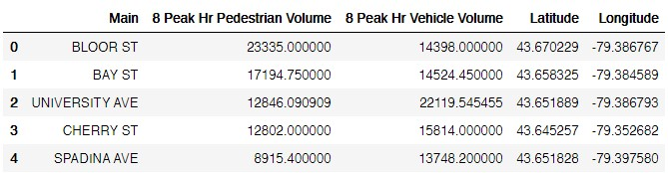

Figure 1 The snippet of pedestrian and vehicle volumes after being grouped by the main road.

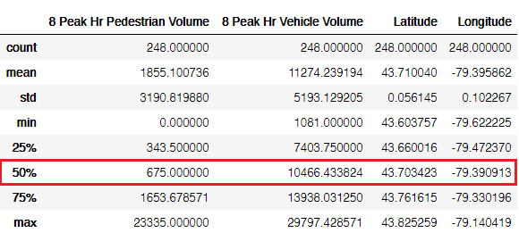

Figure 2 The statistics summary of pedestrian and vehicle volumes during peak hour.

We want our candidate neighborhoods to be lively. Hence, we filter out the roads. In this example, we only show the roads with an average of pedestrian volume above **1,200** or vehicle volume above **12,000** during peak hour (above ~70%). This gives us **139** main roads.

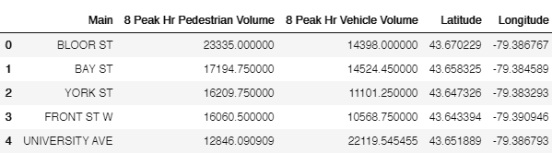

*Figure 3 The first five rows of the filtered main roads*

Finally, we can visualize the roads using the Folium Python module from the given coordinates. The map shows a glimpse of the city’s busiest roads, where many are located around downtown, which is not surprising.

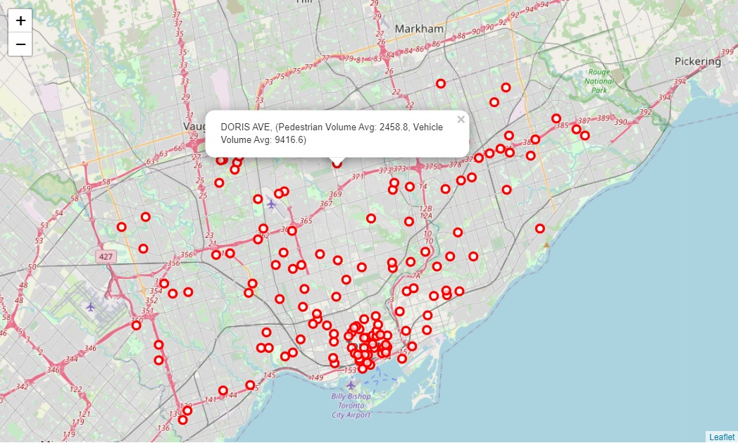

*Figure 4 The city’s busiest main road distribution*

### Crime Statistics:

Next, we analyze the crime statistics from 2014 to 2019. It gives us 206,435 crime incidents segmented by police divisional boundaries, neighborhoods, and Major Crime Indicators (MCI). Toronto Police Service divides the major crimes into 5 categories scattered to 17 divisions and 140 neighborhood IDs.

Figure 5 The first five rows of major crime data. The red box is the police service division code we are interested in.

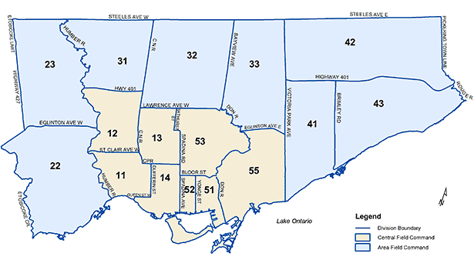

Figure 6 [Toronto Police Service Divisional Boundaries](http://www.torontopolice.on.ca/)

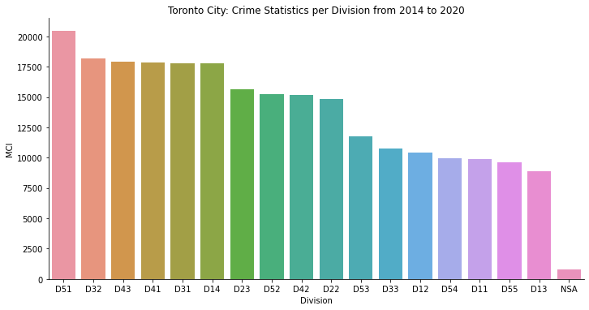

*Figure 7: Toronto City crime stats per Division from 2014 to 2020*

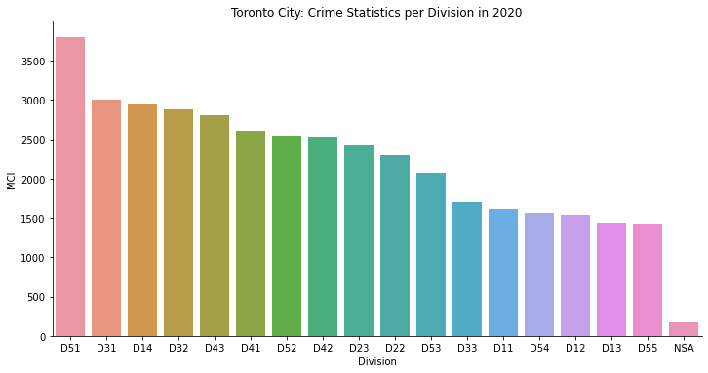

*Figure 8: Toronto city crime stats per Division in year 2020*

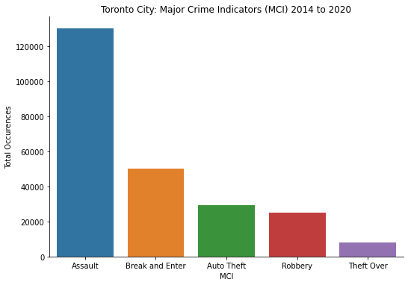

*Figure 9: Toronto city MCI from 2014 to 2020*

Among the 5 MCI, Assault incidents are still number one occurred the most for 6 consecutive years. During the same period, several divisions are consistent about their crime rates. Thus, the divisions fall into three categories:

High Crime Rates (D51, D43, D41, D32, D31, D14) Middle Crime Rates (D52, D42, D23, D22) Low Crime Rates (D55, D54, D53, D33, D13, D12, D11) Finally, to pick the area of interest, the candidates are expected to be:

* safe - having low crime rates
* lively - crowded by people, vehicles, and easy to access close to downtown.

Therefore, the divisions qualified are D55, D54, D53, and D13. These divisions cover:

* Central Toronto (D53)
* East York (D53, D54, D55)
* York (D13)

D11, D12 are mostly west end of Toronto which are safe but not lively. In the next section, we will explore the neighborhoods inside Central Toronto, East York, and York as the selected boroughs.

### Neighbourhoods Analysis:

Lastly, we have built a neighborhood data frame that contains 103 postal codes, 10 boroughs, neighborhood names inside each borough, and their coordinates. Since we are interested in neighborhoods inside Central Toronto, East York, and York only, we filter the data frame. This results in having 3 boroughs and 19 neighborhoods.

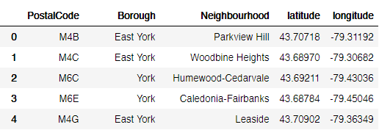

Figure 10 The first 5 neighborhoods of the selected boroughs

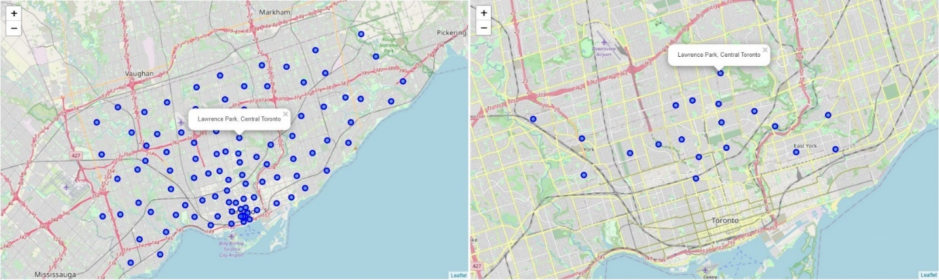

Figure 11: Left — the map of city neighborhood distribution. Right —The neighborhood distribution for Central Toronto, East York, and York.

Given the coordinates information, we can use the Foursquare API to access the 2nd data source, explore the neighborhoods, and get the top 100 venues within a radius of 1 km for each. As a result, it returns 900 venues with 170 unique venue categories.

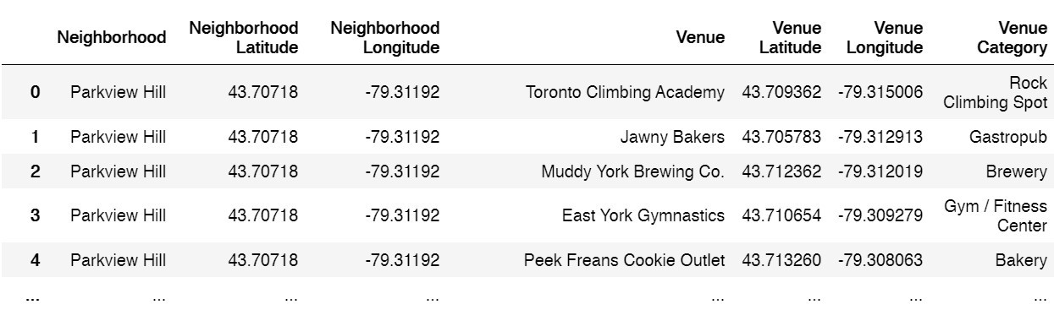

Figure 12: The first 5 venues returned for Parkview Hill Neighborhood

For each neighborhood, we can create the top 10 venues based on occurrences as follows.

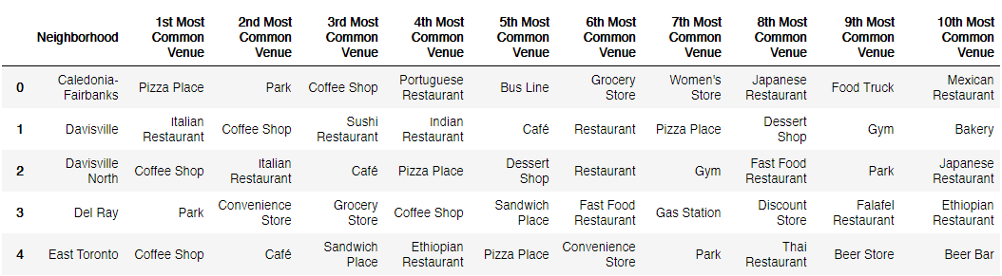

Figure 13: The first five rows of the neighborhood’s top 10 venues.

The data frame above indicates that we have the same venue categories returned to different neighborhoods. We can use this idea to cluster the neighborhoods based on their venues representing services and amenities.

## Clustering the Neighborhoods:

We will run the k-Means algorithm to build a clustering model with a different number of clusters (k). The features will be the mean of the frequency of occurrence of each venue category. Using Silhouette Score Elbow, we can measure and plot the clustering performances.

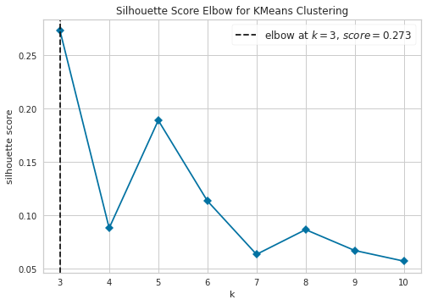

*Figure 14: Graph to show best k value to be used*

We can inspect that the best k value for this task is 3. Hence, we will have **3 cluster neighborhoods** at the end.

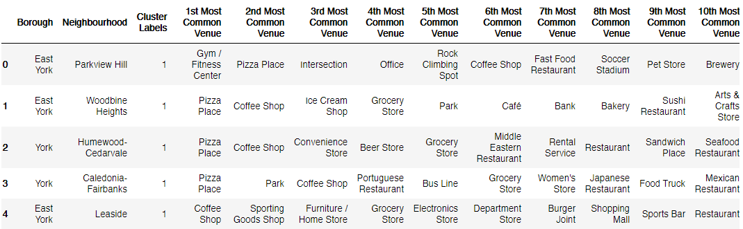

Figure 14 The result of k-Means with k = 3. Now, the table has a cluster label for each neighborhood.

# Results

Finally, Let’s visualize the resulting clusters!

Figure 14 Neighborhood Clusters

As a result, we can examine venues listed inside each cluster and define the discriminating venue categories that distinguish them.

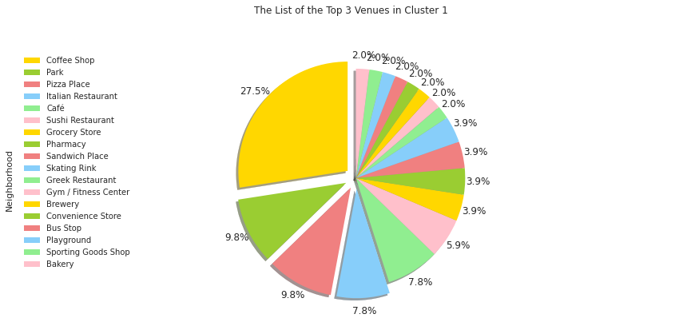

Figure 15 The list of top 3 venues in cluster 1

Figure 16 The list of the Top 5 Venues in Cluster 0, Cluster 2

* ***Cluster 0: “Stores”***

The first cluster contains 1 neighborhood only, with the Stores as the first most common venue.

* ***Cluster 1: “Coffee Shop and Restaurant Venues”***

The second cluster holds 16 neighborhoods, with the coffee shop, restaurant, and Cafe venues appear to be the most common ones.

* ***Cluster 2: “Gym and Fitness Center”***

The third cluster includes 1 neighborhood with Gym and Fitness Center as the most occurrence venue category.

# **Discussion:**

The project’s main goal is to determine the best location for opening a coffee shop business in Toronto. Discussing what locations can be considered “the best” may vary, but we can equate it as the most conducive ones by considering the following criteria:

* + 1. **Safety**
* The conducive locations are supposed to be safe; hence we analyze the crime statistics for all divisions of Toronto Police Service. We conclude that divisions D55, D54, D53, D33, D13, D12, D11 have the lowest crime rates. These cover Central Toronto, West Toronto, York, and East York.
  + 1. **Demographics and Accessibility**
* **Vehicle and foot traffic** are important when we choose a location for the new coffee shop. We have shown the busiest main roads in the city where many are located around downtown. Then, we consider focusing on Central Toronto, York, and East York at first. However, this would come to waste if those people are not our target demographic. Hence, we need to understand the target market and discuss it further with the team.
* **Accessibility** is also another part to consider. Soon, if we have picked a few location candidates, knowing how and why your customers will get to your location are crucial, such as street visibility, parking slot, and location convenience. Thus, further discussion with the team is again needed.
  + 1. **Neighboring businesses**
* Neighboring businesses can affect the profitability both positively and negatively.
* Cluster 1 has the most coffee shops and restaurants in their neighborhoods. Although these businesses can be in different categories, they could all contend with the products you serve. Therefore, **cluster 1 is not recommended.**
* **Cluster 0 and 2 are recommended neighborhoods** to inspect further. However, it is also wise to consider other businesses or amenities surrounding the area to complement your offerings. For example, if we target people who spend their morning or afternoon outside, cluster 0 might be a good choice since it has “Stores” as the most common venue.

# **Conclusion:**

Finding the best location to start a business can be challenging and quite frustrating due to many uncertainties. However, we can quickly gain meaningful insights into the city and its neighborhoods with data available today. This helps everyone, including entrepreneurs, business owners, and stakeholders, to make solid decisions based on facts.